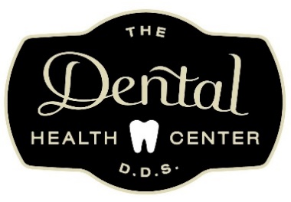
PATIENT SCREENING FORM
Do you have a fever or felt feverish lately? | YES | NO |  | YES | NO
Do you have shortness of breath or difficulties breathing THAT IS UNCOMMON TO YOU? | YES | NO |  | YES | NO
Do you have a persistent cough? | YES | NO |  | YES | NO
Do you have any other flu-like symptoms? | YES | NO |  | YES | NO
Have you experienced recent loss of taste or smell? | YES | NO |  | YES | NO
Are you in contact with any confirmed COVID-19 patients? | YES | NO |  | YES | NO
Patient Name: | Pre-appointment | In-office
 | Date: | Date:
Please print this form off before your appointment and fill it out. Then bring the form with you to your dental appointment. If you answer yes to any of these questions, we may delay your appointment. If you answered yes and feel you should be tested see the list with your area’s information: https://www.cdc.gov/publichealthgateway/healthdirectories/healthdepartments.html

(to be taken at the clinic) TEMPERATURE READING:_________________
• Patients and parents/guardians: Please limit extra companions on your trip to The Dental Health Center to essential people in order to reduce the number of people in the reception area.
• After in-office screening and after further discussion, patient was recommended to contact their primary care physician. YES NO

